3

Two toy cars, black and yellow, travel along a 2 metre track.

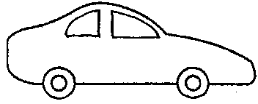
START
STOP
2 metres
black
yellow
20 cm
10 cm

The yellow car starts 20cm ahead of the black car.
Both cars start at the same time.
Both cars stop at the same time. The yellow car is then 10 cm ahead.

(a) Which car was faster?

Tick ONE box ()

❑ | The black car.
❑ | The yellow car.
❑ | Both had the same speed.

(b) All of the following statements are correct. But which is the best explanation for the answer above?

Tick ONE box ()

❑ | Both cars started and stopped at the same time.
❑ | The black car travelled further than the yellow car in the same time.
❑ | At the end, the yellow car was further from the START position.
❑ | Another reason: _______________________________________  _____________________________________________________

